<$ScrKeepWithNext><$Scr_H::2><$Scr_Ps::0>
Factbase
<!$Scr_H::2><!$Scr_Ps::0>
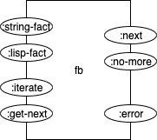
Figure <$n:figure:Factbase>

The factbase part holds the factbase in internal format.

The FB part has 4 input pins and 3 output pins.

The input pin <$Scr_Cs::1>:string-fact<!$Scr_Cs::1> accepts a string which contains one fact. The fact is converted to internal format and stored in the factbase.

The input pin <$Scr_Cs::1>:lisp-fact<!$Scr_Cs::1> accepts a fact in Lisp format and stores the fact in the factbase.

The input pin called <$Scr_Cs::1>:iterate<!$Scr_Cs::1> is fired to request the FB part to set itself up for iteration through the factbase. The FB produces no output(s) when this pin is fired.

The input pin called <$Scr_Cs::1>:get-next<!$Scr_Cs::1> is fired to request the FB to send the next fact out of its <$Scr_Cs::1>:next<!$Scr_Cs::1> output pin. The FB, also, advances its iteration through the factbase when this pin fires.

The output pin called <$Scr_Cs::1>:next<!$Scr_Cs::1> sends out one fact every time the <$Scr_Cs::1>:get-next<!$Scr_Cs::1> input is fired, if there are more facts in the iteration.

The output pin called <$Scr_Cs::1>:no-more<!$Scr_Cs::1> signals that a single iteration has finished and that there are no more facts to be sent to the <$Scr_Cs::1>:next<!$Scr_Cs::1> output pin.

If anything goes wrong, some kind of error event is sent to the output pin <$Scr_Cs::1>:error<!$Scr_Cs::1>.

The logic of the FB component can be expressed as a state machine in Fig. <$n:figure:FBStateMachine>.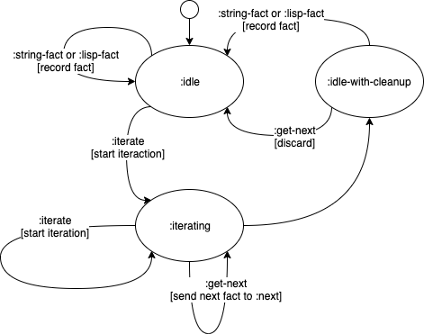
Fig. <$n:figure:FBStateMachine>, FB State Machine

The FB must “clean up” its input, as exactly 0 or 1 <$Scr_Cs::1>:get-next<!$Scr_Cs::1> triggers can be queued up at the point that it changes state.

